Project Report

Aawaj

-By Kammula Keerthi
22EEB0B21
- Video to audio converter

- Audio to text converter

Summary:

Aawaj is a versatile multimedia application enabling users to seamlessly convert videos to audio files and transcribe audio content to text. The application offers a streamlined experience, incorporating features such as audio playback and document saving. Aawaj stands as a comprehensive tool for multimedia conversion, fostering accessibility and convenience for users seeking efficient video-to-audio and audio-to-text transformations.

Introduction

Significance:

The significance of this project lies in addressing the growing need for efficient and user-friendly tools that facilitate multimedia manipulation.

- On one hand, it allows users to extract audio content from video files, catering to situations where users may want to listen to the audio separately or convert it into a different format.

- On the other hand, the project also empowers users to convert audio files into text, offering a valuable tool for transcription, accessibility, and content analysis.

Objective:

This dual-purpose functionality serves various user needs and scenarios, addressing the following objectives:

1. Efficient Multimedia Handling

2. Content Consumption Flexibility

3. Provide Real-time User Feedback

4. User-Friendly Interface

5. Local Storage Convenience

Technologies, libraries, and modules used in the project :

- Tkinter:
Tkinter is used for developing the graphical user interface (GUI) of the application, providing a set of tools for creating windows, buttons, and other GUI elements.

- speech_recognition:
This library is employed for audio processing, specifically for recognizing speech in audio files. It allows the application to convert spoken words into text.

- pydub:
Pydub is used for audio processing and manipulation. In this project, it plays a key role in converting video files to audio files.

- moviepy.editor:
Moviepy is utilized for video processing, enabling the extraction of audio from video files. It contributes to the video-to-audio conversion functionality.

- tempfile:
Tempfile is used for creating temporary files, which is especially used in the project for managing temporary audio and document files.

Implementation

Open the GUI application

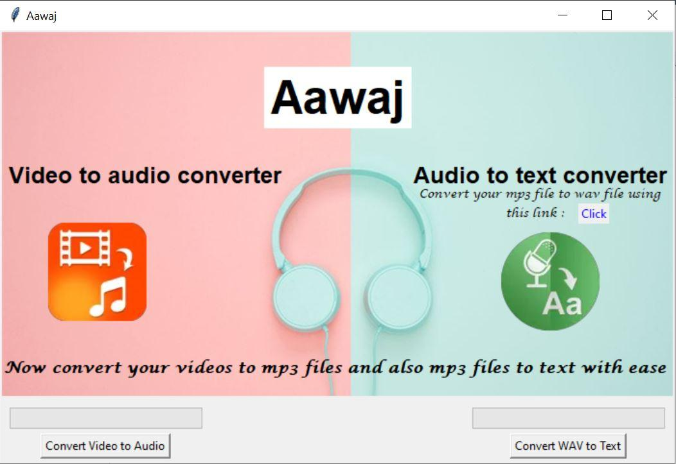

Steps to convert video to audio

Step 1: To convert video to audio, click the button Convert Video to Audio and the user can upload the video.

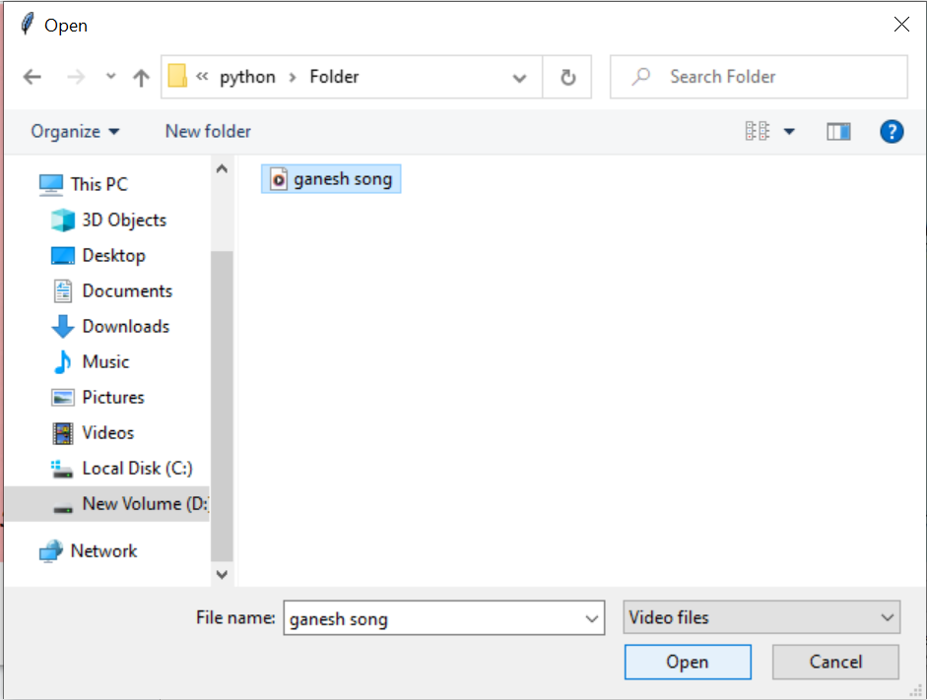

Step 2: While the video is getting converted to audio, we can see the progress of loading bar.

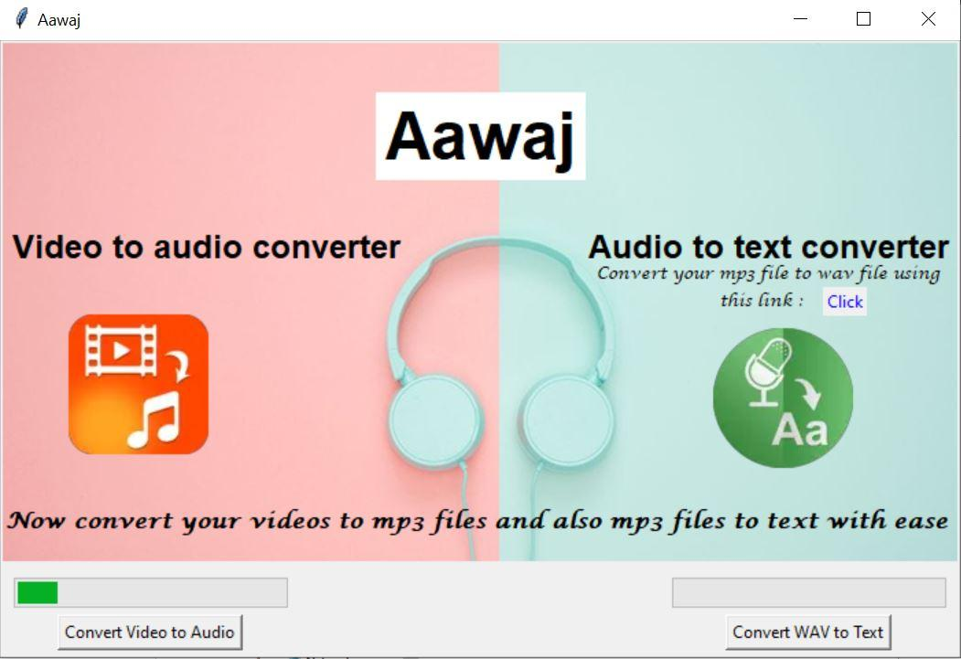

Step 3: We get an option to listen to the audio file

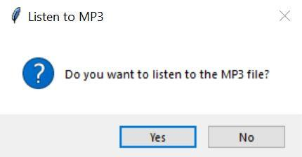

Step 4: If the user clicks yes, he can listen to the mp3 file using windows media player. A temporary mp3 file is created here.
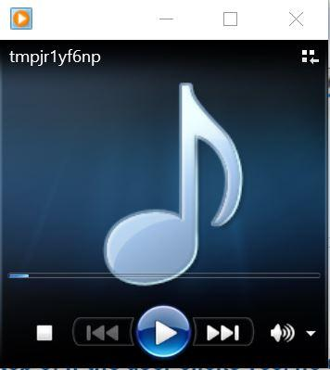

Step 5: The user then gets an option to save the mp3 file.
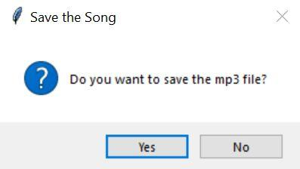
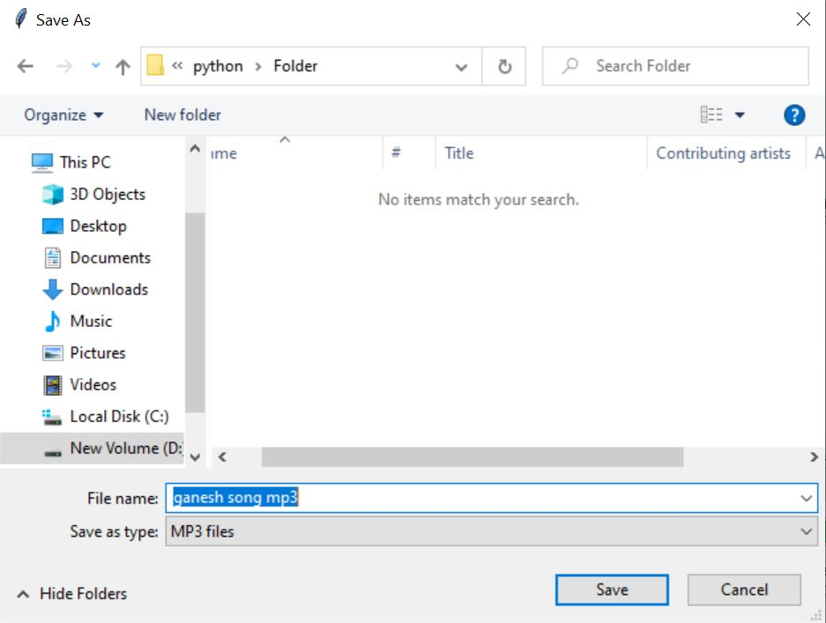
Step 6: On clicking Yes, the mp3 file is saved. The user has the flexibility to save it in the location of their choice.
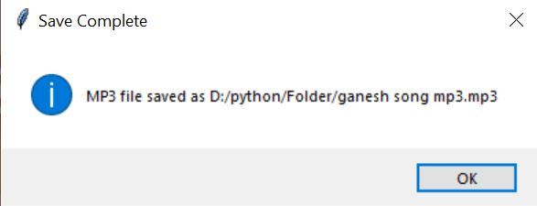
Step 7: After mp3 the file is saved, the user gets a page displaying that the file is saved.

Steps to convert audio to text

Step 1: To convert an mp3 file to text, click the convert mp3 to text button and select the appropriate mp3 file.
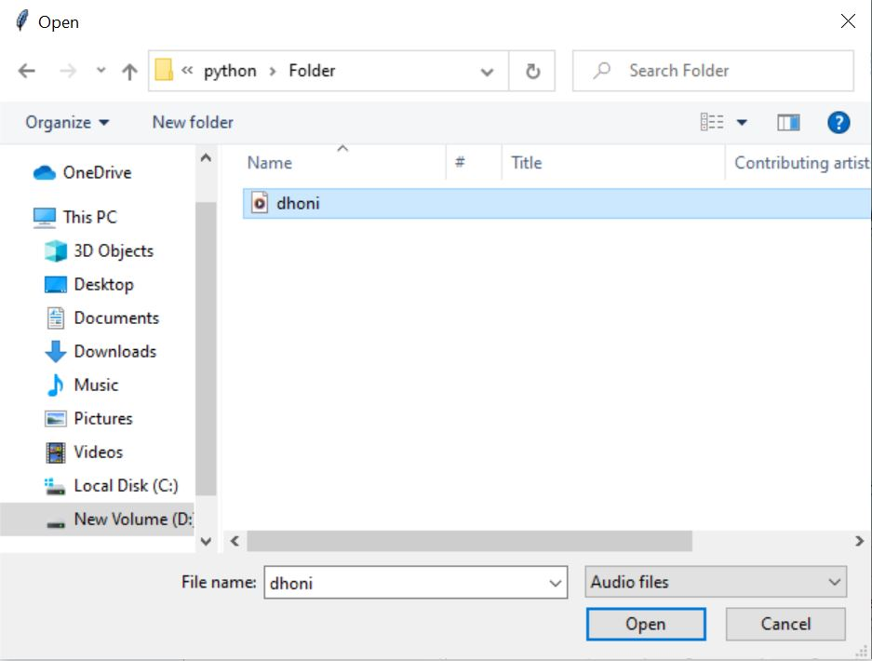

Step 2: While the mp3 file is getting converted to text, the loading bar progresses.
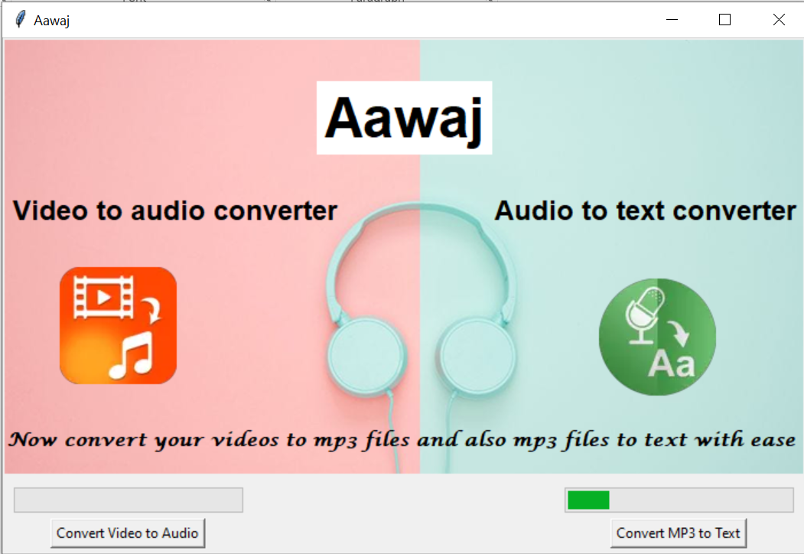

Step 3: After converting mp3 to text and storing it in word document, we get an option to open the docx file. The docx file is stored as a temporary file.
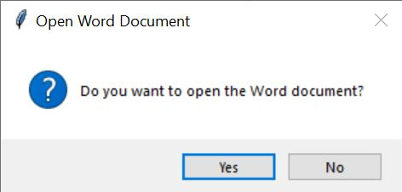

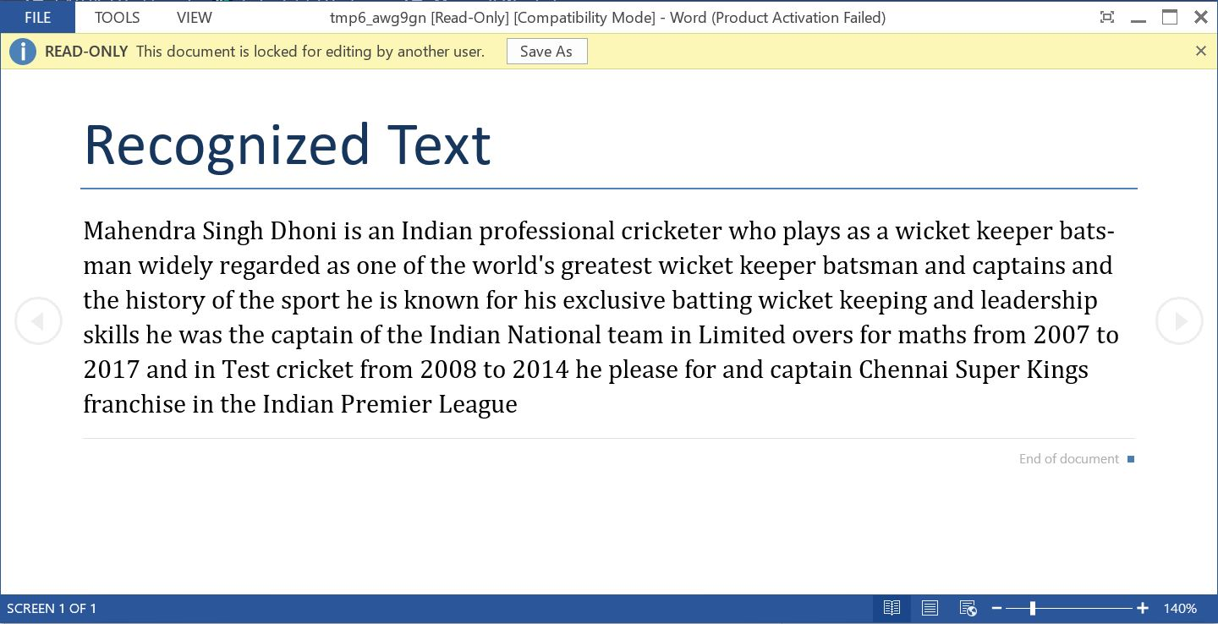
Step 6: On clicking Yes, the word document with the text is opened.

Step 7: Then the user gets an option to save the word document.
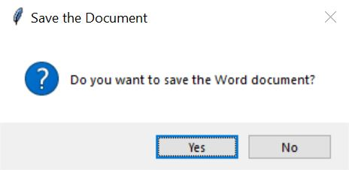
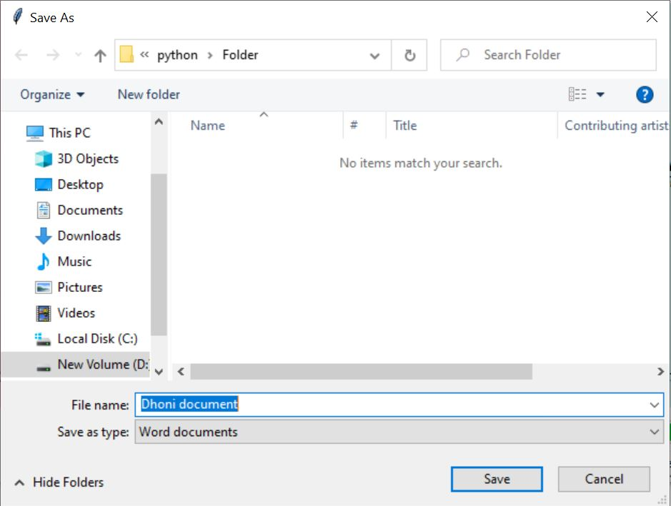
Step 8: On clicking Yes, the user can save the word document file in the desired location.
Step 9: After the word document file is saved, the user gets a page displaying that the file is saved.

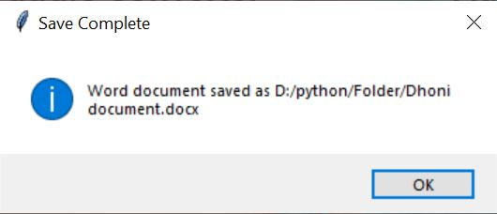
Conclusion

In conclusion, the "Aawaj" project is a solution designed to adapt to the evolving needs of users in a digital landscape saturated with diverse multimedia content. The dual-purpose functionality addresses various scenarios, from personal audio extraction to professional transcription services, making it a valuable asset for content creators, educators, and individuals with accessibility needs.

Github repository link:
https://github.com/Keerthi29062005/Aawaj--Python-project.git

